Certainly! In business, especially in the context of Lean Manufacturing and the Toyota Production System, waste refers to any activity that does not add value to the end product. Here's an explanation of the common types of waste:
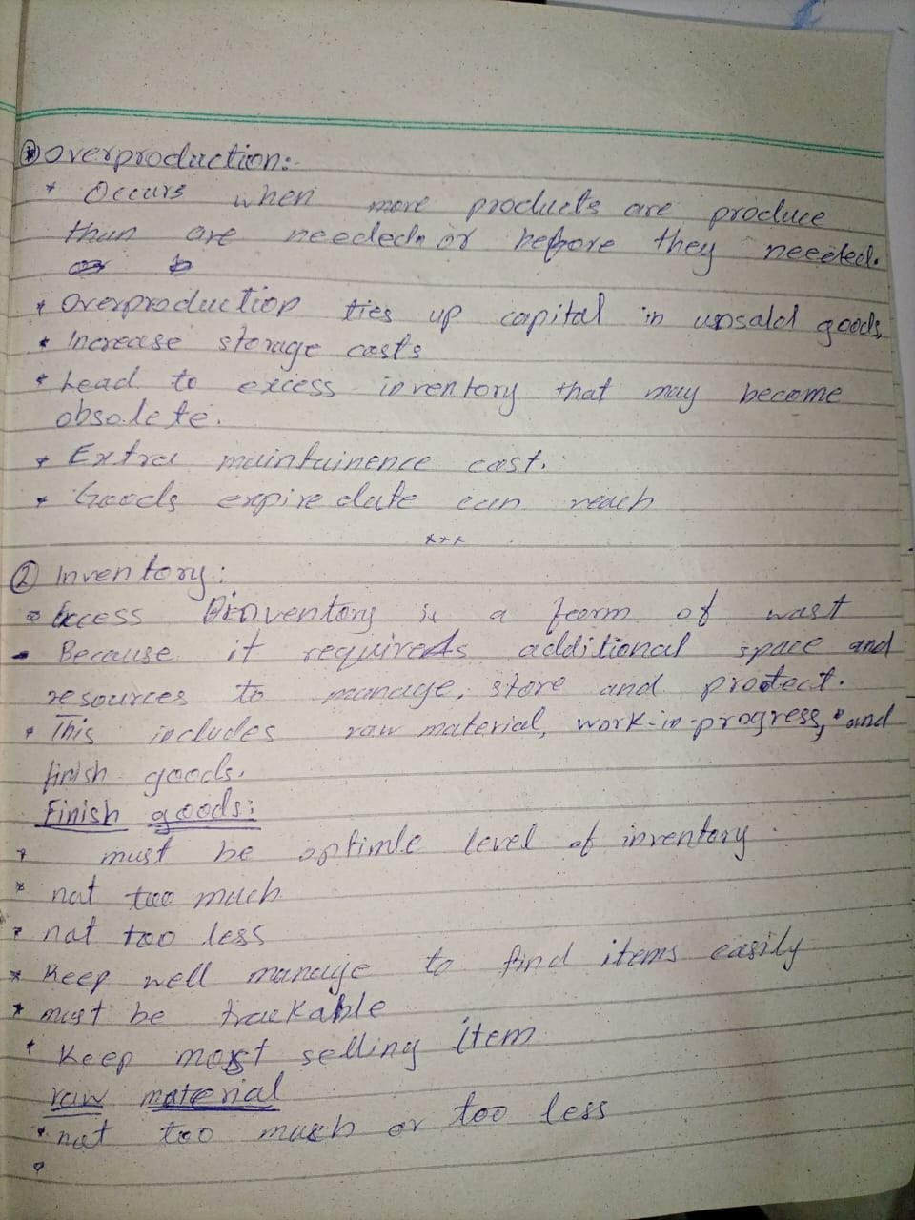
1. Overproduction: This occurs when more products are produced than are needed or before they are needed. Overproduction ties up capital in unsold goods, increases storage costs, and can lead to excess inventory that may become obsolete.
2. Inventory: Excess inventory is a form of waste because it requires additional space and resources to store, manage, and protect. This includes raw materials, work-in-progress, and finished goods. Excess inventory can hide problems such as defects, equipment downtime, and unbalanced production.
3. Repair/Rejects:
- Repair/reject waste occurs when products do not meet quality standards and require rework or are discarded as rejects.
- This waste includes all efforts related to fixing defective products.
- Repairing or rejecting products consumes time and resources that could be better spent on producing quality goods correctly the first time.
Causes:
Poor Quality Control
Using low-quality raw materials can lead to defects in the final product.
poorly maintained machinery can produce defective items.
Complex Design
Lack of Standardization
Impacts:
Increased Costs: Repairing or reworking defective products incurs additional labor, material, and overhead costs. Discarding rejects leads to wasted resources.
Time Consumption: Time spent on repairs or rework could be used more productively on manufacturing new products.
Resource Wastage: Materials, labor, and energy used to produce defective products are wasted.
Customer Dissatisfaction: Defective products reaching customers can lead to returns, complaints, and damage to the company’s reputation.
Reduced Efficiency: Defects disrupt the production flow and can lead to bottlenecks and delays.

4. Motion:
- Motion waste refers to any unnecessary movement by people, equipment, or machinery that does not add value to the product or service.
- Unnecessary movement of people, equipment, or machinery can waste time and energy.
Causes:
Poor Workplace Layout: Inefficient arrangement of workstations, tools, and materials can lead to excessive movement.
Lack of Organization: Disorganized workspaces where items are not easily accessible can cause employees to spend extra time searching for tools or materials.
Inefficient Processes: Processes that require repetitive or unnecessary steps can lead to increased motion.
Untrained worker.
Less accessibility of tools.

Impacts:
Reduce productivity
Lower Efficiency: Time spent on unnecessary motion is time not spent on value-adding activities, decreasing overall efficiency.
Higher Costs: Additional time and effort spent on non-value-adding activities can increase labor costs.
Slower Cycle Times: Inefficient movements can extend the time required to complete tasks, resulting in longer cycle times.
Error risk.

5. Processing:
This waste occure when unnecessary activities performing in a process that do not add value to the product.
involves performing more work or using more expensive processes than necessary to produce a product.
having multiple steps that do not add value.
Streamlining processes can reduce this type of waste.
Causes:
Complex Procedures: Having overly complicated or redundant processes that add unnecessary steps.
Lack of Standardization: Variability in how tasks are performed can lead to inconsistent and excessive processing.
Poor Design Specifications: Product designs that require unnecessary features or excessively tight tolerances.
Inadequate Understanding of Customer Needs: Misinterpreting or overestimating what the customer values can lead to adding unnecessary features or functions.
Inefficient Use of Technology: Using advanced technology or machinery when simpler methods would suffice.
Impacts:
- Increased Costs: More materials, labor, and time are consumed in over-processing, raising production costs without increasing value.
- Wasted Resources: Resources such as energy, raw materials, and time are wasted on non-value-adding activities.
- Longer Lead Times: Excessive processing can extend production times, delaying delivery to customers.
- Reduced Flexibility: Complex processes can make it harder to adapt to changes in customer demand or market conditions.
- Customer Dissatisfaction: Customers may not appreciate or be willing to pay for unnecessary features, potentially leading to dissatisfaction.

6. Waiting:
Waiting waste occurs when there are delays in the production process. This can happen when employees, equipment, or materials are not in use because they are waiting for something else to be completed. Waiting is a non-value-adding activity that does not contribute to the final product or service.
Causes:
- Unbalanced Workloads: When tasks are not evenly distributed, some workers may have to wait for others to complete their work.
- Machine Downtime: Equipment breakdowns or maintenance issues that halt production.
- Supply Chain Delays: Waiting for materials or components to arrive from suppliers.
- Approval Processes: Delays due to waiting for approvals or decisions from managers or other departments.
- Information Flow: Lack of timely or adequate information needed to proceed with a task.
- Scheduling Issues: Poor planning and scheduling can lead to periods where workers or machines are idle.
Impacts:
- Reduced Productivity: Time spent waiting is time not spent on productive activities, lowering overall efficiency.
- Increased Costs: Idle labor and equipment still incur costs without contributing to output.
- Extended Lead Times: Delays in one part of the process can cascade, lengthening the time it takes to deliver the final product to the customer.
- Customer Dissatisfaction: Longer lead times and delays can result in missed deadlines and unmet customer expectations.

7. Transport:
Transport waste refers to the unnecessary movement of products, materials, or information within a business. This movement does not add value to the product or service and can increase the risk of damage, loss, and delays.
Unnecessary movement of products between processes or locations is a waste of time and resources.
Causes:
- Poor Facility Layout: Inefficient arrangement of workstations, storage areas, and equipment that necessitates excessive movement.
- Long Supply Chains: Extended distances between suppliers, production sites, and customers can increase transportation needs.
- Batch Processing: Large batch sizes may require materials to be transported to and from storage areas multiple times.
- Separate Storage Locations: Storing raw materials, work-in-progress, and finished goods in different locations can lead to excessive transport.
- Inadequate Planning: Poor planning and coordination can result in unnecessary movement of materials or products.
- Complex Distribution Networks: Multiple handoffs and transfers in distribution networks can lead to excessive transportation.
Impacts:
- Increased Costs: More transportation means higher fuel, labor, and maintenance costs for vehicles and handling equipment.
- Extended Lead Times: Excessive movement can slow down the production process and delay delivery to customers.
- Risk of Damage or Loss: More handling and movement increase the chances of products being damaged or lost.
- Decreased Efficiency: Time spent on transportation is time not spent on value-adding activities, reducing overall efficiency.
- Environmental Impact: Increased transportation contributes to higher emissions and environmental degradation.

8. Line Layout:
Line layout waste occurs when the physical arrangement of production or workstations in a facility is inefficient. This inefficiency can result in times consuming, unnecessary motions, reduced productivity and higher operational costs.
A well-designed line layout minimizes movement and maximizes workflow efficiency.
Causes:
- Poor Initial Design: Inadequate planning and design of the layout can lead to inefficient workflows.
- Changes in Production Requirements: Shifts in product design or demand without corresponding changes in layout can create inefficiencies.
- Lack of Flexibility: Rigid layouts that cannot easily adapt to changes in production volume or product mix.
- Inadequate Space Utilization: Inefficient use of available space can lead to congestion or underutilization of floor space.
Impacts:
- Increased Travel Time: Workers spend more time moving between workstations, which reduces the time spent on value-adding activities.
- Reduced Productivity: Inefficient layouts lower overall productivity by wasting time and effort.
- Increased Lead Times: Inefficient layouts can slow down production, extending the time required to deliver products to customers.
- Time consuming
- Energy waste

9. Long Lead Times:
Long lead times refer to extended durations between the start and finish of a process, which can delay product delivery and reduce responsiveness to customer demands.
They can be caused by complex processes, large batch sizes, or poor scheduling. Reducing lead times can increase responsiveness to customer demand and reduce inventory levels.
Lead time is the total time it takes from the initiation of a process until its completion.
Causes:
- Complex Processes: Intricate and multi-step processes that require coordination among various departments or stages.
- Inefficient Workflow: Bottlenecks, delays, and unbalanced workloads within the production or service delivery process.
- High Work-In-Progress (WIP): Large amounts of WIP can slow down the overall process as resources are tied up in unfinished goods.
- Supply Chain Delays: Slow or unreliable supply of raw materials and components from suppliers.
- Batch Processing: Producing or handling items in large batches can lead to waiting times for batch completion before the next stage begins.
- Poor Scheduling: Inefficient planning and scheduling of tasks, resources, and equipment.
- Quality Issues: Defects and rework can cause delays and extend lead times.
- Lack of Automation: Manual processes that could be automated to save time.
- Inadequate Communication: Slow or ineffective communication among team members or departments.
Impacts:
- Reduced Customer Satisfaction: Delays in delivering products or services can lead to dissatisfaction and lost business.
- Higher Costs: Long lead times can increase holding costs for inventory and WIP, as well as overhead costs.
- Decreased Flexibility: Longer lead times make it harder to respond quickly to changes in customer demand or market conditions.
- Cash Flow Issues: Extended periods between paying for materials and receiving payment for finished goods can strain cash flow.
- Competitive Disadvantage: Competitors with shorter lead times can capture market share by delivering faster.

JIT
- JIT is a management philosophy that aims to eliminate waste in all forms by producing goods only as they are needed, thereby minimizing inventory levels and associated costs.
- Produce (or order) right items in the right quantities at the right time at the right place.
- JIT can be defined as an integrated set of activities designed to achieve high-volume production using minimal inventories (raw materials, work in process, and finished goods)
Big JIT (also called Lean Management) is a philosophy of operations management that seeks to eliminate waste in all aspects of a firm’s production activities: human relations, vendor relations, technology, and the management of materials and inventory
Little JIT focuses more narrowly on scheduling goods inventory and providing service resources where and when needed
key Principles of JIT:
● Elimination of waste (Muda): Waste refers to any activity that does not add value from the customer's perspective. Examples include overproduction, waiting time, transportation, excess inventory, motion, and defects.

● Continuous improvement (Kaizen): Kaizen involves making small, incremental improvements to processes, systems, and behaviors on a continuous basis. It emphasizes empowering employees at all levels to identify and implement improvements.

● Pull-based production system: In a pull-based system, production is triggered by actual customer demand rather than forecasts or production schedules. This helps to minimize inventory and ensures that resources are utilized efficiently.

● Just-in-time inventory management: JIT inventory management involves maintaining minimal inventory levels. This helps to reduce carrying costs, rental costs, and improve cash flow.

● Employee empowerment and involvement: JIT encourages employee involvement and empowerment by fostering a culture of teamwork, collaboration, and continuous learning. Employees are encouraged to contribute ideas for improvement and are actively involved in problem-solving.

JIT Inventory Reduction
- Use a pull system to move inventory
- Reduce lot size
- Reduce setup time
- Develop Just-in-Time delivery systems with suppliers
- Deliver directly to point of use
- Perform-to-schedule
- Use group technology
QRM
focuses on reducing lead times across all operations, thereby improving overall organizational efficiency and responsiveness.
The key principles of QRM include:
- Focus on Lead Time Reduction: The primary goal of QRM is to reduce lead times throughout the entire manufacturing process. This includes all stages from the initial order to the final delivery.
- Organizational Structure: QRM promotes the restructuring of organizational teams into what are called QRM cells. These cells are cross-functional teams that are empowered to manage their own work processes. This helps to streamline communication and decision-making, which reduces delays.
- Unified Vision: Everyone in the organization, from top management to shop floor workers, should understand and be committed to the QRM principles. This unified vision ensures that all efforts are aligned towards the common goal of lead time reduction.
- System Dynamics: QRM emphasizes the understanding and management of system dynamics, including the variability and interdependencies of different processes. By optimizing these dynamics, companies can better manage flow and reduce bottlenecks.
- Strategic Variability Reduction: QRM identifies and reduces variability that does not add value to the customer, focusing efforts on those activities that contribute directly to customer satisfaction and on-time delivery.
- Time-Based Competition: QRM supports the idea that time, not cost, is the primary driver of competitiveness. By reducing lead times, companies can respond more quickly to market demands and changes, thereby gaining a competitive edge.

ISO
ISO, the International Organization for Standardization, is an independent, non-governmental international organization that develops and publishes international standards

1. Objectives
The primary objectives of ISO include:
- Standardization: Developing and promoting international standards to facilitate global trade, enhance product quality and safety, and promote innovation and efficiency.
- Consistency: Ensuring consistency in products, services, and systems across different countries and industries.
- Efficiency: Improving efficiency in manufacturing and services by providing a framework for best practices.
- Safety and Quality: Enhancing safety and quality in various sectors, including technology, manufacturing, healthcare, and the environment.

2. Roles
ISO performs several key roles:
- Development of Standards: ISO brings together experts to develop standards that address various aspects of technology and business.
- Publication: Publishing standards that are adopted and implemented globally.
- Facilitation: Facilitating international trade by ensuring compatibility and interoperability of products and services.
- Harmonization: Harmonizing national and regional standards with international standards to avoid technical barriers to trade.
- Advisory: Providing guidance to industries and governments on best practices and standards.

3. Process of Certification
The process of obtaining ISO certification typically involves the following steps:
- Preparation: An organization prepares by understanding the specific ISO standard requirements relevant to its operations and conducting a gap analysis.
- Documentation: Developing and documenting processes, procedures, and policies that meet the ISO standards.
- Implementation: Implementing the documented processes and ensuring they are followed throughout the organization.
- Internal Audit: Conducting internal audits to verify that the processes meet the ISO standards and identifying any areas for improvement.
- Management Review: Reviewing the system at the management level to ensure its effectiveness and alignment with business goals.
- Certification Audit: An external certification body conducts a thorough audit of the organization’s processes and systems.
- Corrective Actions: Addressing any non-conformities identified during the certification audit.
- Certification: If the organization meets all the requirements, the certification body issues the ISO certificate.
- Surveillance Audits: Regular follow-up audits to ensure continued compliance with the standards.

4. Series
ISO publishes standards in various series, each focused on different aspects of quality, safety, and efficiency. Some of the most well-known ISO series include:
- ISO 9000 Series: Focuses on quality management systems (QMS). ISO 9001 is the most widely recognized standard in this series.
- ISO 14000 Series: Pertains to environmental management systems (EMS). ISO 14001 is the key standard in this series.
- ISO 45000 Series: Covers occupational health and safety management systems. ISO 45001 is the main standard.
- ISO 27000 Series: Deals with information security management systems (ISMS). ISO 27001 is the primary standard.
- ISO 22000 Series: Focuses on food safety management systems (FSMS).
- ISO 50000 Series: Pertains to energy management systems (EnMS).
- ISO 26000: Provides guidance on social responsibility.

Full members (or member bodies) influence ISO standards development and strategy by participating and voting in ISO technical and policy meetings. Full members sell and adopt ISO International Standards nationally.
Correspondent members observe the development of ISO standards and strategy by attending ISO technical and policy meetings as observers. Correspondent members that are national entities sell and adopt ISO International Standards nationally. Correspondent members in the territories that are not national entities sell ISO International Standards within their territory.
Subscriber members keep up to date on ISO’s work but cannot participate in it. They do not sell or adopt ISO International Standards nationally.

World Trade Organization (WTO)
The World Trade Organization (WTO) is an intergovernmental organization that regulates and facilitates international trade between nations. The organization aims to ensure that trade flows as smoothly, predictably, and freely as possible.
Here are some key aspects of the WTO:
- Purpose and Functions:
  - Trade Negotiations: The WTO facilitates trade negotiations between its members aimed at reducing barriers to trade.
  - Implementation and Monitoring: It oversees the implementation of the agreements reached by its members and monitors their compliance.
  - Dispute Settlement: The WTO provides a mechanism for resolving trade disputes between member countries.
  - Capacity Building: It offers technical assistance and training for developing countries to help them build their trade capacity.

